**Course: Advance Bio Informatics**

**Module Title: Reporting Server**

**Module No: 89**

**Reporting Server**

Data stored in databank is of no use if users cannot use it or interact with it. To give users its access, some user interface programs can be written. These user interface programs should allow users to retrieve data from generated databank.

**Criteria for Search**

User interface programs can also be used to allow users to retrieve data based on some criteria such as actual data source from where data came originally, accession no, author name of data.

**Formats for Reports**

Web services can also be written to expose data of databank to external world. Some reporting tool can be used to generate reports from databank for further analysis. Data can also be presented to users into visual formats such as graphs, charts etc.

**Reporting Server**

For better scalability purpose, user interface programs should be stored on separate server.

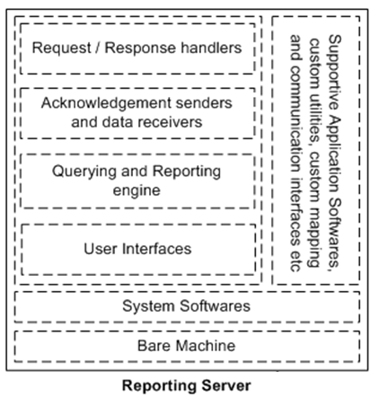

**Request / Response Handlers** – For enabling information exchange with *Data Server* through request and response mechanism

**Acknowledgement senders and data receivers** – To receive requested data from *Data Server* and send acknowledgement back to *Data Server* (if required)

**Querying and Reporting Engine** – Utilities like query builder, query optimizer, report designer, report generator etc.

**User Interfaces** – GUIs for generating reports.

**Supportive application softwares** – MS office, Editors, Browsers, Report designing tools, etc